IT Spend/Usage for CoMans and CoPacks
Final Results
- In what region is your company located?
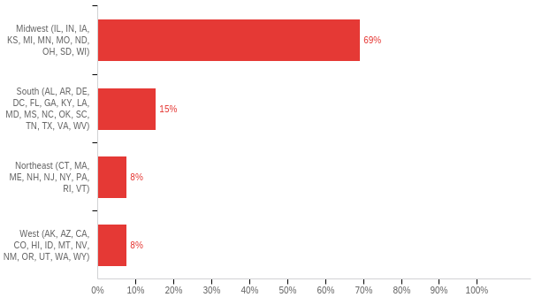

Field | Count
In what region is your company located? | 13

In what region is your company located? | Percentage
Midwest (IL, IN, IA, KS, MI, MN, MO, ND, OH, SD, WI) | 69%
South (AL, AR, DE, DC, FL, GA, KY, LA, MD, MS, NC, OK, SC, TN, TX, VA, WV) | 15%
Northeast (CT, MA, ME, NH, NJ, NY, PA, RI, VT) | 8%
West (AK, AZ, CA, CO, HI, ID, MT, NV, NM, OR, UT, WA, WY) | 8%
Total | 13

- What is your company's annual revenue?
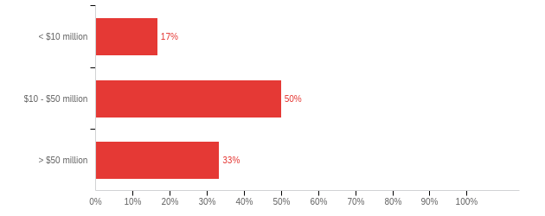

Field | Count
What is your company's annual revenue? | 12

What is your company's annual revenue? | Percentage
< $10 million | 17%
$10 - $50 million | 50%
> $50 million | 33%
Total | 12

- How many individuals currently perform IT duties in your organization?
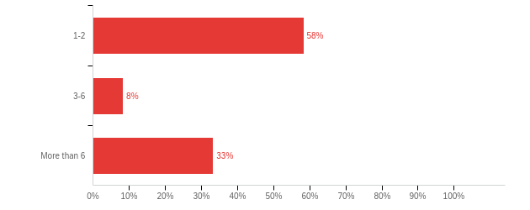

Field | Count
How many individuals currently perform IT duties in your organization? | 12

How many individuals currently perform IT duties in your organization? | Percentage
1-2 | 58%
3-6 | 8%
More than 6 | 33%
Total | 12

- In general, what is your current IT spend per employee (including temporary associates)?

- 50,000
- We do not have an IT department
- 96000
- 1667
- 1000
- 25000

- Does your company currently use an ERP style system software?
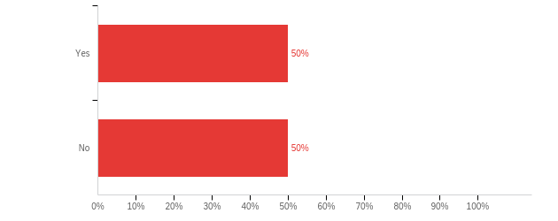

Field | Count
Does your company currently use an ERP style system software? | 10

Does your company currently use an ERP style system software? | Percentage
Yes | 50%
No | 50%
Total | 10

- What ERP software does your company currently use the most?
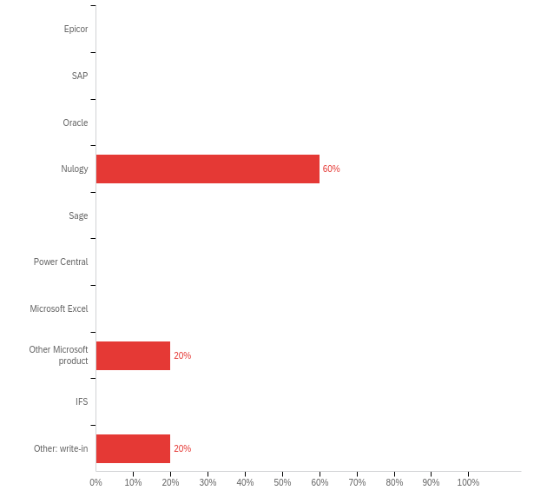

What ERP software does your company currently use the most? - Selected Choice | Percentage
Epicor | -
SAP | -
Oracle | -
Nulogy | 60%
Sage | -
Power Central | -
Microsoft Excel | -
Other Microsoft product | 20%
IFS | -
Other: write-in | 20%
Total | 5
- Are you planning to use an ERP style system software?
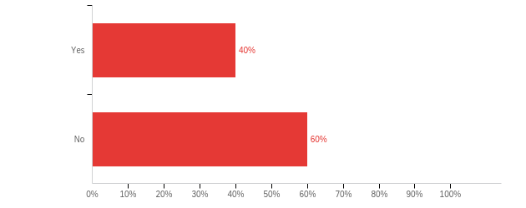

Field | Count
Are you planning to use an ERP style system software? | 5

Are you planning to use an ERP style system software? | Percentage
Yes | 40%
No | 60%
Total | 5

- What ERP software are you planning to use?
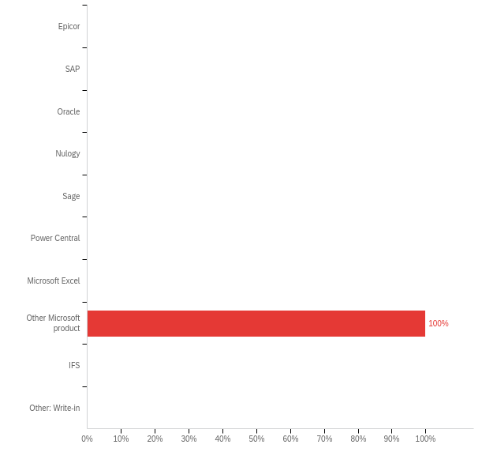
What ERP software are you planning to use? - Selected Choice | Percentage
Epicor | -
SAP | -
Oracle | -
Nulogy | -
Sage | -
Power Central | -
Microsoft Excel | -
Other Microsoft product | 100%
IFS | -
Other: Write-in | -
Total | 1
- What type of ERP have you implemented or are you planning to implement?
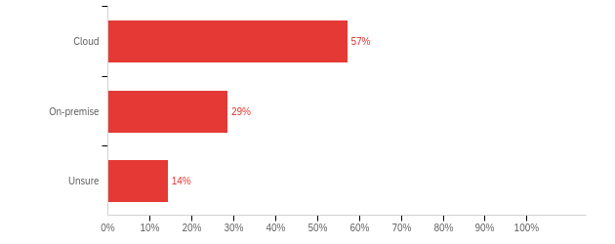

Field | Count
What type of ERP have you implemented or are you planning to implement? | 7

What type of ERP have you implemented or are you planning to implement? | Percentage
Cloud | 57%
On-premise | 29%
Unsure | 14%
Total | 7

- How are internet security issues, regarding ERP, being resolved within your company?

- Revised security software, Back-up servers, New authentication requirements, Cyber security consultants
- Nulogy handles
- Many ways - 2FA, phishing simulation, backups, notifications, detection, etc...

- How do you officially share information with suppliers and/or end users?
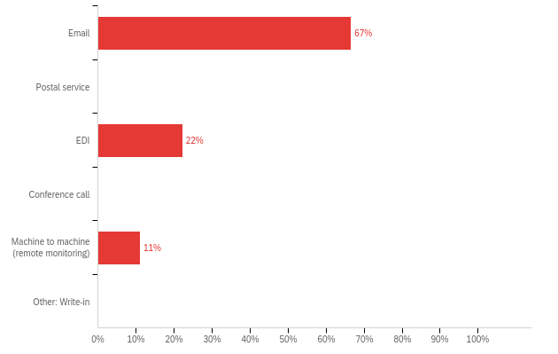

Field | Count
How do you officially share information with suppliers and/or end users? - Selected Choice | 9

How do you officially share information with suppliers and/or end users? - Selected Choice | Percentage
Email | 67%
Postal service | -
EDI | 22%
Conference call | -
Machine to machine (remote monitoring) | 11%
Other: Write-in | -
Total | 9

- How do you manage EDI (electronic data interchange)?
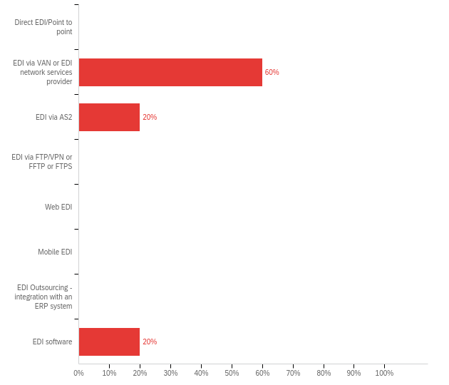
Field | Count
How do you manage EDI (electronic data interchange)? | 5

How do you manage EDI (electronic data interchange)? | Percentage
Direct EDI/Point to point | -
EDI via VAN or EDI network services provider | 60%
EDI via AS2 | 20%
EDI via FTP/VPN or FFTP or FTPS | -
Web EDI | -
Mobile EDI | -
EDI Outsourcing - integration with an ERP system | -
EDI software | 20%
Total | 5
- Is your company currently investing in modernizing equipment?
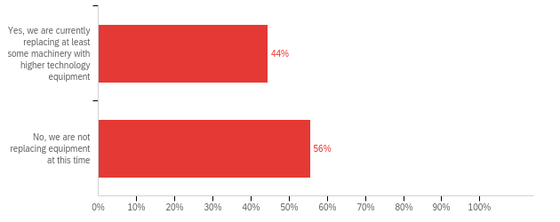

Field | Count
Is your company currently investing in modernizing equipment? | 9

Is your company currently investing in modernizing equipment? | Percentage
Yes, we are currently replacing at least some machinery with higher technology equipment | 44%
No, we are not replacing equipment at this time | 56%
Total | 9

- Which of the following are you using digital systems for: quality, maintenance, or warehousing?
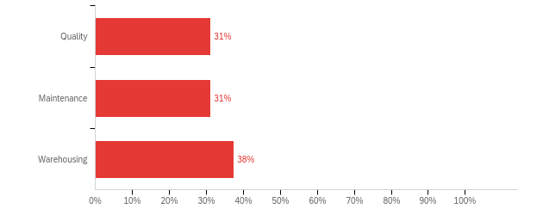

Which of the following are you using digital systems for: quality, maintenance, or warehousing? | Percentage
Quality | 31%
Maintenance | 31%
Warehousing | 38%
Total | 16

- Which digital systems do you currently use for quality?
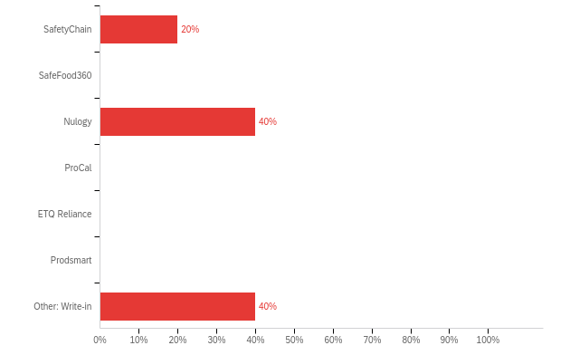
Field | Count
Which digital systems do you currently use for quality? - Selected Choice | 5

Which digital systems do you currently use for quality? - Selected Choice | Percentage
SafetyChain | 20%
SafeFood360 | -
Nulogy | 40%
ProCal | -
ETQ Reliance | -
Prodsmart | -
Other: Write-in | 40%
Total | 5

Other: Write-in - Text
- QCloud

- Which digital systems do you currently use for maintenance?
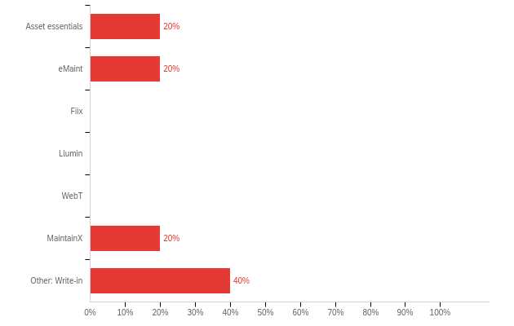
Field | Count
Which digital systems do you currently use for maintenance? - Selected Choice | 5

Which digital systems do you currently use for maintenance? - Selected Choice | Percentage
Asset essentials | 20%
eMaint | 20%
Fiix | -
Llumin | -
WebT<A | -
MaintainX | 20%
Other: Write-in | 40%
Total | 5

Other: Write-in - Text
- Upkeep
- Hippo

- Which digital systems do you currently use for warehousing?
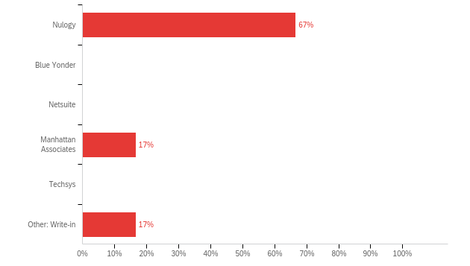

Field | Count
Which digital systems do you currently use for warehousing? - Selected Choice | 6

Which digital systems do you currently use for warehousing? - Selected Choice | Percentage
Nulogy | 67%
Blue Yonder | -
Netsuite | -
Manhattan Associates | 17%
Techsys | -
Other: Write-in | 17%
Total | 6

- Has your company implemented IoT with the ERP system or are you planning to implement it?
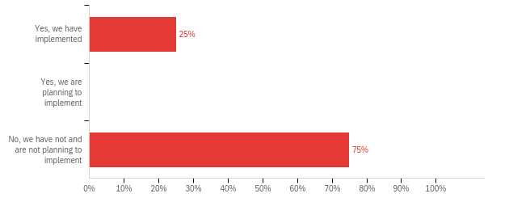

Field | Count
Has your company implemented IoT with the ERP system or are you planning to implement it? | 8

Answer | %
Yes, we have implemented | 25%
Yes, we are planning to implement | -
No, we have not and are not planning to implement | 75%
Total | 100%

- Which IoT systems do you currently use or are you planning to use?
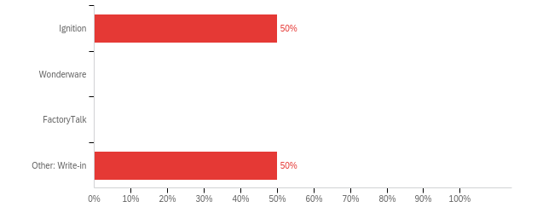

Field | Count
Which IoT systems do you currently use or are you planning to use? - Selected Choice | 2

Which IoT systems do you currently use or are you planning to use? - Selected Choice | Percentage
Ignition | 50%
Wonderware | -
FactoryTalk | -
Other: Write-in | 50%
Total | 2

